Marketplace
Recreation, Leisure & Learning
Program Guide

Spring 2018
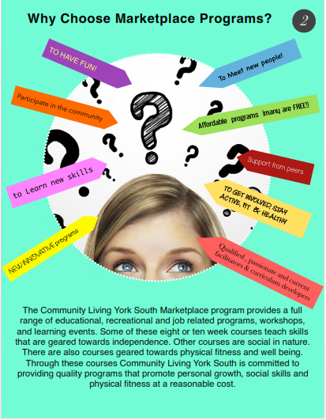
Register | Cost | Dates | Time | Location | Program |  | MARKHAM
Town of Markham 318977 | $147.04 | April 9th to June 18th | 10:00am-12:00 noon | Armadale Community Centre | Everyday Healthy Cooking | Monday
Marketplace | $30.00 | April 9th to June 18th | 1:00pm-3:00pm | 101 YMCA Blvd., Unionville | Fitness at YMCA
Town of Markham 318975 | $147.04 | April 10th to June 12th | 10:00am-12:00 noon | Armadale Community Centre | Cooking Made Easy | Tuesday
Marketplace | $75.00 | April 10th to June 12th | 10:00 am-12:00 noon | Aaniin Library | Literacy/ Book Club
Marketplace | $25.00 | April 17; May 1, 15, 29; June 12, 26 | 1:00pm-3:00pm | CLYS Markham Office | Knitting Group (bi-weekly)
Marketplace | FREE | April 10, 24; May 8, 22; June 5, 19 | 1:00pm-3:00pm | Markham Village Library | Computer Essentials (bi-weekly)
Register | Cost | Dates | Time | Location | Program |  | MARKHAM (continued)
Town of Markham 324925 | $77.00 (resident)/ $92.00 (non) | April 11th to June 13th | 9:30am-12:00 | Stiver Mills Hall | Relationship Course | Wednesday
Marketplace | $30.00 | April 11th to June 20th | 1:00pm-3:00pm | 101 YMCA Blvd., Unionville | Fitness at YMCA
Marketplace | $75.00 | April 12th to June 14th | 10:00am-12:00 | Tony Wong Place | Budgeting Basics | Thursday
Town of Whitchurch-Stouffville 3710 | $115.00 | March 29th to May 31st | 5:00pm-7:00pm | Ballantrae Community Centre | Chef’s Corner
Marketplace | Based upon activites | April 13, 27; May 11, 25; June 8, 22 | 6:00pm-8:00pm | CLYS Markham Office (1st meeting) | Friday Night Social Club | Friday

Register | Cost | Dates | Time | Location | Program |  | RICHMOND HILL
Marketplace | $25.00 | May 2nd to June 27th | 10:00am-12:00 noon | Richmond Hill Police Station (171 Major Mackenzie Dr.) | Social Connections and Interaction | Wednesday
Marketplace | $95.00 | April 12th to June 28th | 6:00pm-8:00pm | Welcome Centre Richmond Hill (9325 Yonge St. #31A) | Drama | Thursday
Marketplace | $96.00 | April 13th to June 29th | 6:00pm-8:00pm | Longo’s (10860 Yonge St.) | Cooking | Friday
For Marketplace programs:
Please complete this form and contact marketplace@communitylivingyorksouth.ca or (905) 294-4971 ext. 450 to register.
Payment must accompany registration form before March 30th, 2018.
RICHMOND HILL
Wednesday

Social Connections and Interaction
Description: Interacting and developing skills to communicate with others confidently.
Location: Richmond Hill Police Station (171 Major Mackenzie Dr.)
Time: 10:00am to 12:00 noon
Dates: May 2nd to June 27th
Cost: $25.00
Register with Marketplace Program

Thursday
Drama
Description: A fun way of learning to develop confidence and express oneself.
Location: Welcome Centre Richmond Hill (9325 Yonge Street #31A)
Time: 6:00pm-8:00pm
Dates: April 12th to June 28th
Cost: $95.00
Register with Marketplace Program

Friday
Cooking
Description: Learning to prepare basic meals; taking home recipes to continue making the dishes they learn to prepare.
Location: Longo’s (10860 Yonge St.)
Time: 6:00pm-8:00pm
Dates: April 13th to June 29th
Cost: $96.00
Register with Marketplace Program

MARKHAM
Monday
Everyday Healthy Cooking
Description: In the everyday cooking classes, we open up to the world of cuisine and get in-depth about ingredients, nutrition, equipment selection, and culinary techniques.
Location: Armadale Community Centre (2401 Denison St.)
Time: 10:00am-12:00 noon
Dates: April 9th to June 18th
Cost: $147.04
Register with Town of Markham
Course Code: 318977

Fitness at YMCA
Description: YMCA provides swimming, group fitness classes, free weights, and recreational sports.
Location: 101 YMCA Blvd, Unionville
Time: 1:00pm-3:00pm
Dates: April 9th to June 18th
Cost: $30.00
Register with Marketplace Program
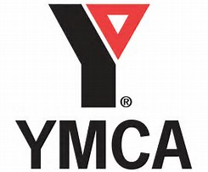
Tuesday
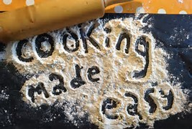
Cooking Made Easy
Description: This course will teach basic cooking and kitchen safety skills in a fun, interactive format.
Location: Armadale Community Centre (2401 Denison St.)
Time: 10:00am-12:00 noon
Dates: April 10th to June 12th
Cost: $147.04
Register with Town of Markham
Course Code: 318975

Literacy/Book Club
Description: Develop basic literacy skills that will enable you to function more effectively in your personal and community life.
Location: Aaniin Library (5665 14th Ave.)
Time: 10:00am-12:00 noon
Dates: April 10th-June 12th
Cost: $75.00 (books and materials included)
Register with Marketplace Program

Knitting Group (bi-weekly)
Description: Learn the basic techniques of knitting stitches
Location: CLYS Markham Office (5694 Hwy 7, Unit #13)
Time: 1:00pm-3:00pm
Dates: April 17; May 1, 15, 29; June 12, 26
Cost: $25.00
Register with Marketplace Program

Computer Essentials (bi-weekly)
Description: Designed to teach various topics pertaining to computers, the Internet, and its impact on our health.
Location: Markham Village Library (6031 Hwy 7)
Time: 1:00pm-3:00pm
Dates: April 10, 24; May 8, 22; June 5, 19
Cost: FREE
Register with Marketplace Program

Wednesday
Relationship Course
Description: This course will explore relationships with friends, acquaintances, strangers and everything in between in order promote healthy lifestyles.
Location: Stiver Mills Hall (Unionville)
Time: 9:30 am-12:00 noon
Dates: April 11th to June 13th
Cost: $77.00 (resident)/ $92.00 (non-resident)
Register with the Town of Markham
Course code: 324925

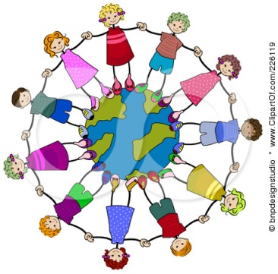

Fitness at YMCA
Description: YMCA provides swimming, group fitness classes, free weights, and recreational sports.
Location: 101 YMCA Blvd, Unionville
Time: 1:00pm-3:00pm
Dates: April 11th to June 20th
Cost: $30.00
Register with Marketplace Program
Thursday
Budgeting Basics
Description: Develop essential skills in making informed financial decisions, becoming a smart shopper, and other everyday budgeting skills to aid in personal and professional endeavors.
Location: Tony Wong Place (25 Deverill Crt.)
Time: 10:00am-12:00 noon
Dates: April 12th to June 14th
Cost: $75.00
Register with Marketplace Program

Chef’s Corner Cooking
Description: Skills taught include independent cooking, kitchen safety, proper use of equipment, food presentation, dinner etiquette and healthy lifestyles.
Location: Ballantrae Community Centre (5592 Aurora Rd.)
Time: 5:00pm-7:00pm
Dates: March 29th to May 31st
Cost: $115.00
Resister with Town of Whitchurch-Stouffville
Course Code: 3710

Friday
Friday Night Social Club
Description: Building healthy relationships in group and community settings.
Location: CLYS Markham Office for first gathering (5694 Hwy 7, Unit #13)
Time: 6:00pm-8:00pm
Dates: April 13, 27; May 11, 25; June 8, 22
Cost: based upon activities
Register with Marketplace Program
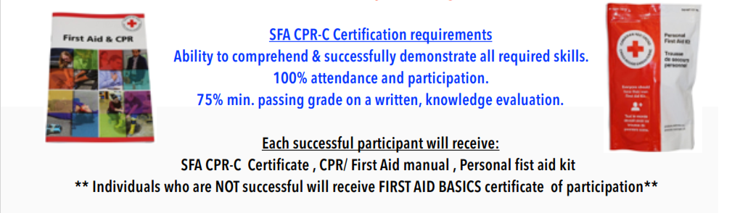
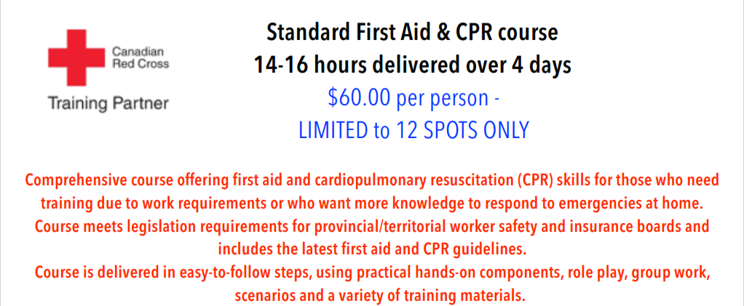
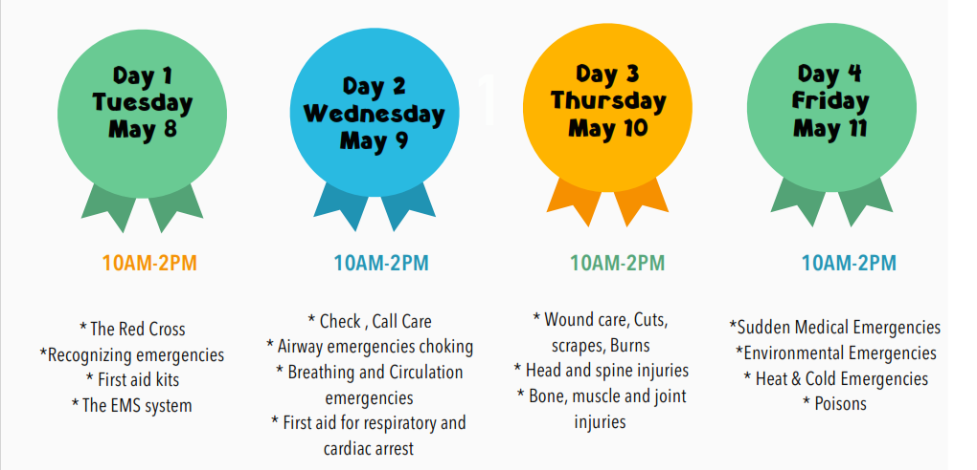
LOCATION: 5694 Hwy#7 (Gallsworthy Rd & Hwy#7 - Markham Office)
Please register with Marketplace
Marketplace Registration Form

Participant Name: ___________________________________ Male: ____ Female: ____
Birthday: ________________________________________________ Age: __________
Full Address: ____________________________________________________________
Telephone #: _________________________ Alternate #: _______________________
Email: ________________________________________________________________
Emergency Contact: ____________________ Emergency Contact #: _______________
Pertinent Medical/Health Info: ______________________________________________
_______________________________________________________________________
Allergies: Yes: ___ No: ___ Describe: ________________________________________
Assisted Devices: ______________________ Mobility Aids: _______________________

Independence Level/Supports to Participate in Marketplace Programs
I require staff support to participate (I will bring my support worker): ______________
I am independent: ________ Partial Supports Required: ________ Describe: ________ _______________________________________________________________________
Read Yes No Write Yes No Large Print Required Yes No Visuals Required Yes No

Communication Supports/Preferred Method of Communication:
PECS: _____ Verbal: _____ ASL: _____ Braille: _____ Other: _____________________
Describe: _______________________________________________________________

Program Name: | Dates: | Time: | Fee:

Signature: __________________________________________ Date: ______________

Register before MARCH 30th 2018 with marketplace@communitylivingyorksouth.ca or 905-294-4971X450

